|  |  |  |
| --- | --- | --- |
| **Problem Chosen** A | **2022 MCM/ICM Summary Sheet** | **Team Control Number** 2200079 |

Power Curves are Conducive to Outdo Riders Themselves

Summary

Higher, faster, stronger – United! For a long time, countless athletes and sports researchers resort to the methods of scientific analysis to constantly break world records, thus breaking through the limits of human beings and demonstrating the spirit and value of **sports** to the whole world. In this paper, we predict the performance of riders in **road cycling competitions** and analyze various factors that affect the results of individual time trials and team competitions, from the perspective of power curves, together with environmental factors, so as to help athletes strive for further improvement.

We build up a **power curve** model based on the *COGGAN* model and a **mechanics model** for cyclists. We define a quantitative concept of fatigue, derive a **Logistic-like** differential equation system, and establish our power curve model, which describes the relationship between the rider’s power output and time under the condition that the rider’s physical condition is determined. The data from *STRAVA* offers important help for us to perfect the power curve model. The mechanical model for cyclists is based on Newtonian mechanics. The effects of environmental factors such as wind speed, wind direction, slope and ground friction, are fully considered.

Firstly, according to the power curve model, the riders are divided into three types according to the **maximum oxygen uptake**, **lactate threshold** and **muscle fiber type**, namely Time Trail Specialist, Climber, and Sprinter. Then we discuss male and female separately and obtain the corresponding power curve. Curves are roughly similar to the statistics-based curves of *COGGAN* et al., thus this model has a high plausibility.

Secondly, by referring to the rider’s mechanical model, we set up a **numerical calculation** algorithm for predicting rider performance, and apply it to the Tokyo Olympics and UCI’s individual time trial events. Taking various factors into account, we design a race track. We conduct a qualitative analysis of the characteristics of different types of players, then analyze the performance of different types of players in the three games.

Thirdly, we make use of the method of controlled variable to explore the effect of **weather**, especially wind speed and direction, on the outcomes of the race. The results indicate that the smaller wind speed may exert positive effect on the results, and the larger wind hinders the athletes' moving. Wind direction also played a role in the outcome of the race.

Fourthly, with the concept of **overtaking action**, we explore the effect of the rider's behavior over the power curve on the results, which is a strictly linear negative correlation, because the rider will experience a "fatigue period". We have also clarified that the game results are sensitive to this behavior, which provides theoretical help for improving performance.

Fifthly, we delve into **drafting** strategies with the help of *Kyle's Law* in team competitions. We rationally arrange everyone's role. The results show that scientific usage of drafting strategies has an important impact on improving the team competition.

To conclude, we further perform a sensitivity analysis of the model, and evaluate our model’s strengths and weaknesses. And by use of our model, we provide recommendations for players who are underperforming in the Tokyo Olympics.

**Keywords:** road cycling, power curve, mechanical model, logistic model.

# Introduction

## Background

2021 marks the centenary of the Road Bike World Championships. At the same time, more and more people are taking part in cycling. The road cycling individual time trial is one of the most talked about races. Different types of players will achieve different results on different tracks.

In response to this phenomenon, scientists put forward the concept of power curve. That is, the maximum power a rider can maintain in a given amount of time. We will determine the rider's power curve based on the rider's physiological characteristics. At the same time, rational use of the power curve can also help the rider to achieve better results.

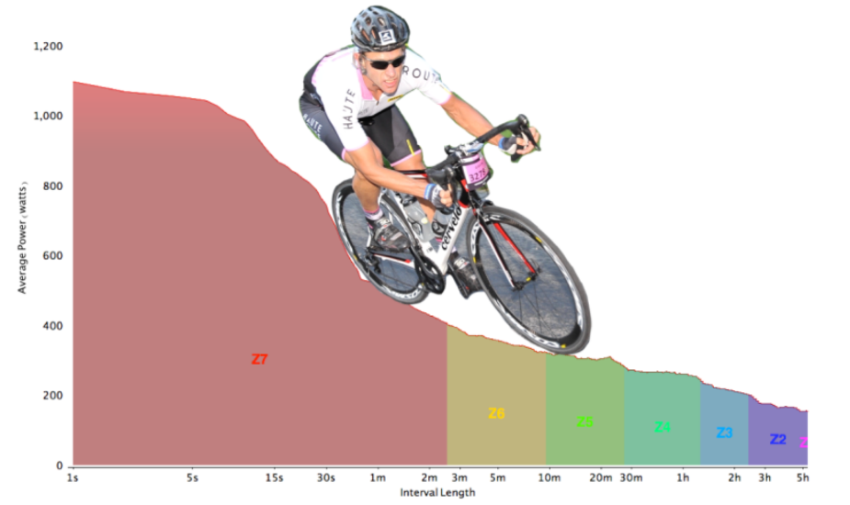

Figure 1: The Power Profile[1]

## Restatement of the Problem

* By studying the physical qualities of different riders, construct power curve models for riders of different types and genders.
* Apply the constructed model to various competitions to verify the accuracy of the model.
* Use the control variable method to study the effect of wind speed and direction on rider rider's performance.
* Study the effect on the results when the rider deviates from the power curve, and determine the sensitivity of the model.
* Extend the model and use the model to develop strategies for team races.

## Our work

This problem requires us to build the rider's power curve model and use the power curve model to help the rider pursue better performance. Our work mainly includes the following:

* Find data related to the physical fitness of riders of different types and genders, and build a rider's power curve model. Analyze the force of the rider during the race and build the rider's mechanical model.
* Apply the constructed model to different races, study the performance of different types of athletes on different tracks, analyze the reasons, and study the impact of wind and overtaking on rider power output.
* Conduct sensitivity analysis on the model, and analyze the advantages and improvements of the model, and finally draw a conclusion.

In summary, the whole modeling process can be shown as follows

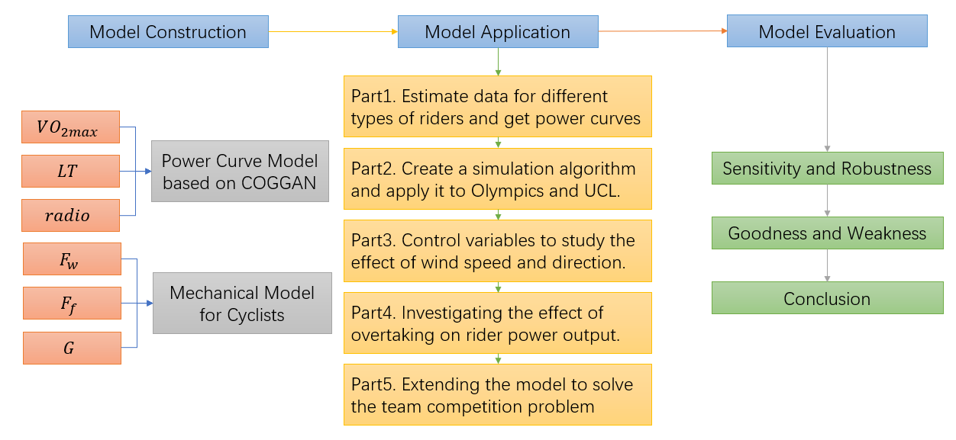

Figure 2：Flow Chart of Our Work

# Assumptions and Explanations

To simplify the problem, we make the following basic assumptions, each of which is reasonable.

* **Assumption 1:** The influence of the athlete's equipment on the power curve is not considered, and the power curve is only related to the athlete's physical factors.

**→Justification:** Most of the equipment of athletes belongs to the top level, and the difference between the equipment used by different athletes is relatively small and can be ignored.

* **Assumption 2:** The athlete's performance in the game is ideal.

**→ Justification:** Player mistakes in the game are very rare, and small mistakes are difficult to avoid and control, so the impact of mistakes on the game can be ignored.

* **Assumption 3:** The race is played in good weather, regardless of extreme weather effects such as rainy days.

**→ Justification:** Most races are not played in bad weather such as rain, and this facilitates modeling.

* **Assumption 4:** No fouls, no drafts in individual time trials.

**→ Justification:** Make sure each rider do his or her best, ignoring the interference of other riders in the individual time trial.

* **Assumption 5:** No resistance exists inside the rider's bike.

**→ Justification:** Professional riders' bicycles are made with top-notch manufacturing technology and have less internal friction, which has a negligible impact on the rider’s performance.

# Notations

Some important mathematical notations used in this paper are listed below.

|  |  |  |
| --- | --- | --- |
| Symbol | Definition | Unit |
|  | the maximum average power that can be generated in the current hour |  |
|  | maximum oxygen uptake |  |
|  | Lactate Threshold |  |
|  | muscle fiber ratio | / |
|  | Fatigue |  |
|  | Athlete's power output under ideal conditions |  |
|  | Sprint power |  |
|  | wind speed |  |
|  | Rolling resistance coefficient | / |
|  | Air drag coefficient | / |
|  | The inclination of the ground to the horizontal |  |
|  | Vector angle of wind and traction |  |
|  | Support force |  |
|  | tractive force |  |
|  | gravity |  |
|  | bicycle friction |  |
|  | windage |  |

# Model Preparation

## Power Curve Model Based on *Coggan* Model

In this section, we use the ***Coggan* model** to solve the rider's power curve equation, which in turn results in the rider's power curve model.

In order to construct a power curve that can reflect the rider's ability, we refer to the model proposed by *Coggan* [1] to solve the rider's power curve equation.represents the maximum oxygen uptake of - type of athlete. represents Lactate Threshold of - type of athlete. represents muscle fiber ratio of - type of athlete.()

is considered the best indicator of an athlete's cardiovascular fitness and a good predictor of their aerobic performance. The maximum power an athlete can produce is approximately proportional to his own maximum oxygen uptake, as following

represents the maximum power that the rider of - can produce, and is pending constant.

Because the total energy a rider can consume during the whole process is limited, the accumulation of fatigue during the race will also affect cyclist’s power output, and as the degree of fatigue intensifies, cyclist's power output decreases faster. So we define **fatigue**  as following

During the competition, each cyclist keeps a constant speed for most of the race, and once the speed is exceeded, that is, when the output power is large, the cyclist will soon be exhausted, and the fatigue will increase sharply. When the output power of the cyclist is gradually approaching the maximum power that the cyclist can generate, because cyclists approach the peak of fatigue, decreases gradually. When the cyclist's speed is slow, the cyclist's fatigue level is low at the same time. It can be seen that there is an inflection in the change curve of fatigue degree. Therefore, the fatigue expression as following

is a constant related to the physical quality of the athlete, and is a constant. According to the definition of fatigue,, so we can get .

The rider's and are the two main factors that affect the degree of fatigue in athletes. Riders with a lower are more likely to feel fatigued during the race. But cyclist with high content of muscle fiber type II can get larger sprint power at the end of the race. The lactic acid content produced by an athlete during exercise can approximately represent the degree of fatigue of the athlete, and the lactic acid threshold is the most important determinant of a rider's endurance riding. The higher the is, the less likely the rider will feel fatigued, which can be approximated as an inverse proportional relationship. Riders with higher can have higher sprint power at the end of the race. Therefore, we can get

is pending constant，and indicates the sprint power of the rider.

In order to get the rider's power curve more accurately, we need to solve the following first-order ordinary differential equation:

This model approximates the ***Logistic* model**. We will explain the solution of this model and the determination of all constants in **5.1.1**.

## 4.2 Mechanical Model for Cyclists

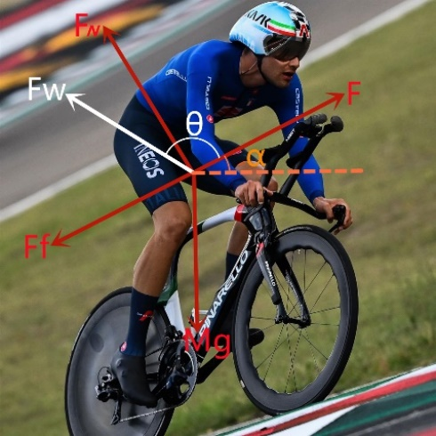

Figure 2：Schematic diagram of the force analysis of the rider。

During the race, the power curve of the rider is related to the force of the athlete. According to assumption 5, there is no energy loss inside the bicycle. Therefore, in the process of riding, athletes are mainly subjected to 5 kinds of forces. They are traction, gravity, friction, wind resistance and support force.

Rider support force depends on rider gravity and the slope of the track. Friction depends on the coefficient of rolling resistance and support force.

The speed of professional riders is about 45km/h. At a speed of 40km/h, overcoming air resistance accounts for more than 80% of all the comprehensive forces that a cyclist must overcome [2]. To calculate the wind resistance experienced by the rider, we quantify the rider resistance through the **drag coefficient equation** using the mathematical model developed by *Kyle* and *Bassett* [3].

Air resistance increases with the square of speed, requiring enormous power to overcome the resistance of the rider and bike [4]. represents the aerodynamic drag coefficient. FA (frontal area) is determined by the area of the bicycle and the rider. We use the mathematical **model of *Kyle* and *Bassett*** [3] to estimate the .

Where is rider height(meters) and is rider weight() .This formula utilizes the body surface area to approximate .

can be calculated from the power curve. According to *Newton*'s second law, the acceleration at this time can be obtained. Use differential equations and *Newton*'s laws of motion to obtain the rider's instantaneous speed and distance.

# Solutions to Problems

## Solutions to problem1: Estimate data and get power curves

### Calculate constants for power curve model

Table 1:Physiological characteristics of professional bike racing champions[5]

|  |  |  |  |
| --- | --- | --- | --- |
| Rider | Thibaut Pinot | Chris Froome | Miguel Indurain |
| VO2max  (ml*kg-1*min-1) | 85 | 84 | 88 |
| Power Output at 4mM Lactate  (watts) | 402 | 505 | 505 |
| Peak Power Output (watts) | - | 525 | 572 |
| Body Fat (%) | - | 9.5 | - |
| Body Weight (kg) | 65 | 67 | 76 |
| Maximal HR (bpm) | - | 170 | 191 |
| Study Authors | Pinot et. al | Bell et. al | Mujika et. al |

Table 2:Power characteristics of some professional Cyclists(means ± SD in W/kg)[5]

|  |  |  |
| --- | --- | --- |
|  | Women(n=8) | Men(n=23) |
| Peak 5-second | 15.22 ± 2.13 | 18.09 ± 2.25 |
| Peak 1-minute | 7.23 ± 0.79 | 9.48 ± 1.14 |
| Peak 5-minute | 4.83 ± 0.32 | 6.10 ± 0.60 |
| *Coggan* FTP-estimate  (95% of peak 20-min) | 4.04 ± 0.36 | 4.86 ± 0.42 |
| Peak 1-hour | 3.50 ± 0.38 | 4.49 ± 0.44 |
| 20-minute | 4.26 ± 0.38 | 5.11 ± 0.45 |

Note: *Coggan* suggests a 5-minute all-out effort prior to obtaining 20-minute value for FTP-estimate

Table 3:*Coggan’s* Power Profile Table.(Only shows data of professional Cyclists)[6]

|  |  |  |  |  |  |  |  |
| --- | --- | --- | --- | --- | --- | --- | --- |
| Men | | | | Women | | | |
| **5s** | 1 min | 5 min | FT | 5s | 1 min | 5 min | FT |
| **24.04** | 11.50 | 7.60 | 6.40 | 19.42 | 9.29 | 6.61 | 5.69 |
| **23.77** | 11.39 | 7.50 | 6.31 | 19.20 | 9.20 | 6.52 | 5.61 |
| **23.50** | 11.27 | 7.39 | 6.22 | 18.99 | 9.11 | 6.42 | 5.53 |
| **23.22** | 11.16 | 7.29 | 6.13 | 18.77 | 9.02 | 6.33 | 5.44 |
| **22.95** | 11.04 | 7.19 | 6.04 | 18.56 | 8.93 | 6.24 | 5.36 |
| **22.68** | 10.93 | 7.08 | 5.96 | 18.34 | 8.84 | 6.15 | 5.28 |
| **22.41** | 10.81 | 6.98 | 5.87 | 18.13 | 8.75 | 6.05 | 5.20 |
| **22.14** | 10.70 | 6.88 | 5.78 | 17.91 | 8.66 | 5.96 | 5.12 |
| **21.86** | 10.58 | 6.77 | 5.69 | 17.70 | 8.56 | 5.87 | 5.03 |
| **22.95** | 11.04 | 7.19 | 6.04 | 18.56 | 8.93 | 6.24 | 5.36 |

Table 4:Numbering of different types of professional riders.

|  |  |
| --- | --- |
|  | 职业类型 |
| 1 | Male Time Trail Specialist |
| 2 | Male Climber |
| 3 | Male Sprinter |
| 4 | Female Time Trail Specialist |
| 5 | Female Climber |
| 6 | Female Sprinter |

We use a part of *Robert Sroka* data which comes from the *STRAVA* exercise tool manufacturer in Table 2 to fit our Power Curve model. We bring it into the equation system, and use the **bisection method** to find the equation to obtain the male Time Trail Specialist constants as follows:

.

According to ***Martin JC* 's law**: in the anaerobic sprint process, professional male road cyclists can often output more than 1000W in about 10-15s[7].So we can estimate that

.

Female Time Trail Specialist constants are listed below

.

Then we can get

### Power Curve of different types of Cyclists

According to the parameters obtained in the previous section, the following images can be obtained:



Figure 3: *STRAVA* and *COGGAN* Data and Power Curve of Average Men Time Trial Specialist

It is clear (also shown by calculation) that our equation fits the *STRAVA* data well. The *COGGAN*

data is larger than the *STRAVA* data at each time. The reasons may be: 1. The *STRAVA* statistics comes from the usual training data so do not show the best level of the cyclists. 2. There may be a gap between *COGGAN* data and *STRAVA* data measurement standards and instruments. But the gap is less than 15%, which can be ignored in the forecast. It is more important that the trend of the model is completely consistent with it. Compared with the *David Johnstone* statistics [6], our model is perfect. (please note the t-axis scale)

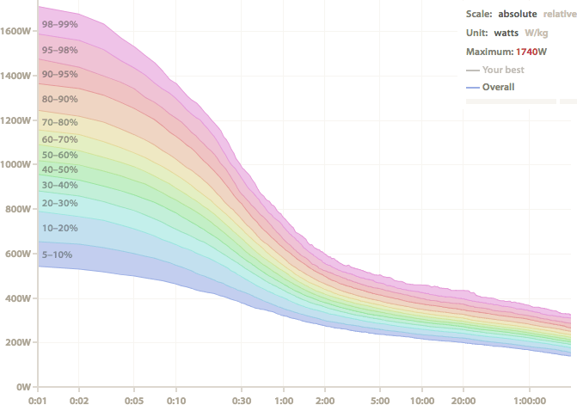

Figure 4：David Johnstone’s Power curve

According to the analysis of *Robert Sroka*[5], the maximum oxygen uptake() plays a decisive role in the capability of athletes. And for the different advantages of different riders, the influencing factors include a variety of internal factors, external factors. And internal factors have the greatest impact, such as, the maximum oxygen uptake (), lactate threshold (, muscle fiber type (, pedaling rhythm, human mechanical efficiency, crank length, saddle height, body fat ratio. Many of them are related to innate talent but can be improved through acquired training, and our model only take some factors into consideration.

represents the turning point from aerobic respiration to anaerobic respiration. The larger is, the stronger the **aerobic respiration** ability and the stronger the ability to maintain a high level of exercise a cyclist can have. In many cases, elite athletes can maintain a long-term power output (80-90% of **FTP**). Muscle fiber type I is known as aerobic muscle, whose percentage in the human body can be increased through aerobic training, such as jogging. Muscle fiber type I is conducive to slow, aerobic, anti-fatigue exercise. Muscle fiber type II is also known as **anaerobic** Muscle, whose percentage can be increased by endurance training, such as weightlifting. It is important for fast, anaerobic sprinting sessions. The ratio of muscle fiber type I to type II() is also an important indicator to measure an athlete. The of an average person is 50/50.

Sprinter has strong short-range sprint ability, strong anaerobic exercise ability, because of a high level and low .

Climber requires sufficient energy supply, with high and high , which can maintain a high level of exercise for a long time.

Time Trail Specialist needs all-around and balanced abilities.

We solve the power curves for different types of riders according to analysis above.

Table 5:Estimation of rider data for different models

|  |  |  |  |  |  |  |  |
| --- | --- | --- | --- | --- | --- | --- | --- |
|  | | 1 | 2 | 3 | 4 | 5 | 6 |
|  | 85.667 | | 90 | 81.3 | 29.439 | 30.927 | 27.938 |
|  | 4 | | 5.2 | 3.1 | 4 | 5.2 | 3.1 |
|  | 1.5 | | 2.333 | 0.667 | 1.5 | 2.333 | 0.667 |
|  | 4.789380 | | 5.031625 | 4.545235 | 1.645817 | 1.729061 | 1.561919 |
|  | -0.174626 | | -0.208924 | -0.100194 | -0.174626 | -0.208924 | -0.100194 |
|  | 18.75 | | 15.67 | 32.68 | 18.75 | 15.67 | 32.68 |



Figure 5: Power Curve of Different Riders

## Solution to Problem2: Create a simulation algorithm and Apply it to races.

### Proposition of a Numerical Simulation Algorithm

Taking both power curve model and mechanical model into consideration, we assume that riders’ power output strictly follows the power curve. And we simulate different types of cyclists’ performance in various competitions and compare it with reality, which confirm the correctness of our model. It can help players find problems and achieve better results.

The rider can choose to briefly exceed the limit on the power curve, but an extra time is needed to recover at lower power levels for a longer period, and then cyclist wastes more time. So we can clarify that the rider achieve his best performance when riders’ power output strictly follows the power curve. According to Assumption 2, the rider's mistakes during the race can be ignored, so we can assume that pro riders’ power output strictly follows his power curve.

According to Assumption 5, the energy loss of mechanical structures is negligible, and the wind direction and speed remain unchanged during the race. We can create an algorithm to simulate the speed and arrival time of the time-trial cyclists. This simulation algorithm’s pseudo-code is as followed.

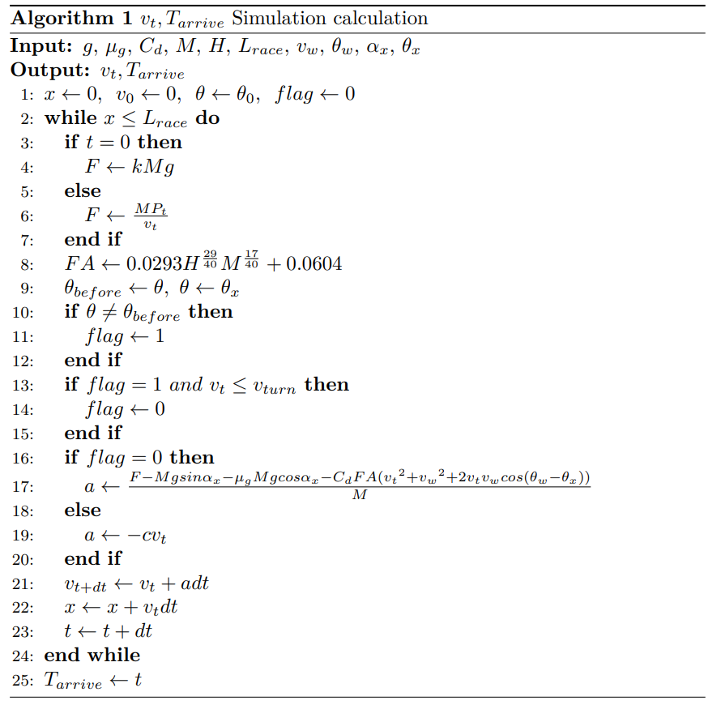

Figure 6:Algorithm Pseudocode for Simulation Computing

### Apply our model to three races

By watching the games and searching on the Internet, we obtain the **Tokyo 2021 Olympic** Road Individual Time Trial and Belgium Flanders **UCI** World Championship Time Trial’s route data[8].We get the relationship between the slope angle(, the road direction angle(), and x. We also get the wind speed and direction data on that day. On the day of the 2021 Olympic Road Individual Time Trial in Tokyo, Japan, , and the wind direction is south. On the day of the individual time trial of the UCI Belgium Flanders World Championships,, and the wind direction is east. We run simulation calculations for different types of riders. The results are shown in the following figures and table.



Figure 7:Some Professional Cyclists’ speed time simulation curve at the Tokyo Olympics



Figure 8: Some Professional Cyclists’ speed time simulation curve at the UCI

It is analyzed that due to the large number of mountains in the Tokyo Olympics, Climber can play better. In reality, the gold medalist is famous for mountain biking, while the Sprinter plays less well because it does not have the endurance of long-distance mountaineering. UCI Belgium's competition venue is flat, which is more favorable for comprehensive players, while Climber plays poorly, and Sprinter plays the worst. Because Sprinter has disadvantage in longer road races. Due to the complex terrain of the Tokyo Olympics venue and the high wind speed at that time, everyone's arrival time was long. The gold medal winner's record was 3300s, which differs from the predicted value by 19.4%. It can be said that the simulation effect is good. The UCI competition is more standard, the wind resistance is lower. The game is extremely frustrating. The gold medalist's record is 2867s, which differs from the predicted value by only 6%. However, the short-term power peak of Sprinter during the sprint is extremely strong, much higher than other competitors. It is observed that during the prediction process, the athletes' level is always higher than the predicted level, indicating that there may be more systematic factors such as skills and equipment that have not been considered, and the athlete's level may not be limited to the power curve. And there is an obvious gap in physical strength between men and women. Due to the lack of physical strength of women, it is impossible to accelerate in the late stage of the hillside road. And female cyclists played better in the UCI because of the flat terrain. And we can find that simulated results in the process are appropriate. When encountering a turn, cyclists needs to decelerate rapidly, and then rapidly increase his speed.

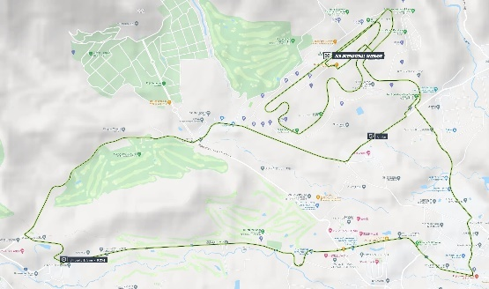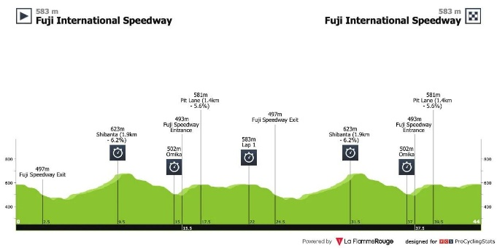

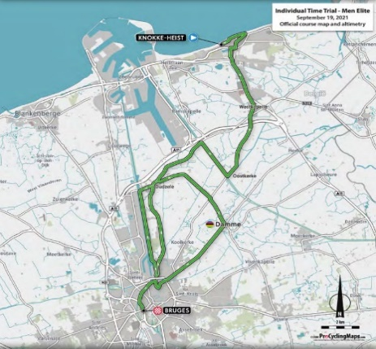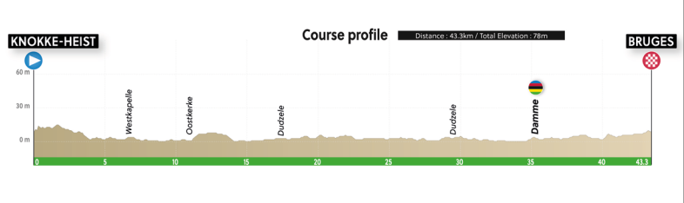

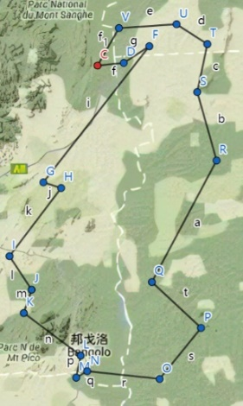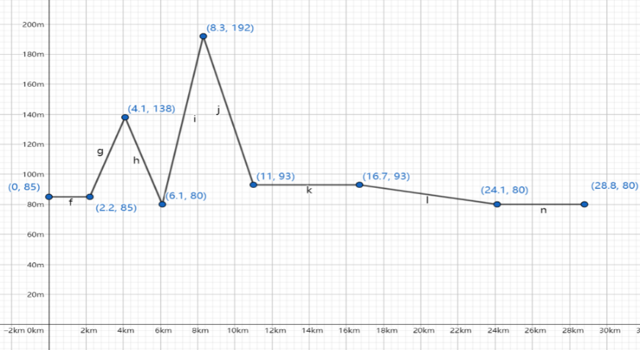

Figure 9: Data of Tokyo Olympics, UCI and our race[9][10]

We comprehensively considered the terrain and weather effects, and design our competition. Our competition took place in Wuhan, Hubei Province. At the start of this competition, there were two key slopes. The overall race track is relatively smooth, and the total distance is short, only 28.8km. The track is slightly favorable for the Sprinter, and conclusions can also be drawn from the results. Sprinter starts quickly and performs well on the first ramp, but falls behind the rest of the bikers on the second key ramp for physical reasons. In the end, Sprinter performs well in the sprints. Climber is weak in sprints so lags behind others, so its performance is worse than Time Trail Specialist. Results are in line with common sense.



Figure 10:Some Professional Cyclists’ speed time simulation curve at Our Race

To sum up, this model is based on the power curve of the athlete, and fully takes into terrain, wind speed, and turning account. This model conforms to common sense and kinematic laws, and the predicted results are in line with reality.

Table 6:Arrival times for different types of riders in 3 races

|  |  |  |  |
| --- | --- | --- | --- |
|  | Tokyo Olympics | UCI | Our Race |
| 1 | 3950 | 3047 | 2190 |
| 2 | 3825 | 3237 | 2280 |
| 3 | 4057 | 3159 | 1951 |
| 4 | 8841 | 4663 | 4017 |
| 5 | 8469 | 4946 | 4145 |
| 6 | 9241 | 5859 | 3677 |

## Solution to Problem 3: the effect of wind speed and direction

Then we analyze the impact of weather on cycling competitions. Precipitation can make ground wet, reduce friction, and obstruct the athlete's vision, forcing the athlete to slow down. According to Assumption 3, we do not take the influence of extreme weather into consideration. So large-scale precipitation is not considered, and the impact of light rain on the game is very small. We only discuss the important wind speed and direction that we are good at dealing with.

### Influence of wind speed on race performance

Let's take Tokyo Olympics as an example. We use the **control variable method**. First, we assume that the wind direction remains south., the wind speed is continuously increased, and plot to analyze the time of male Climber.



Figure 11： In the case of constant wind direction, relationship between arrival time and

It can be seen from the Figure that the time for the rider to complete the race decreases first and then increases with the increase of wind speed. Because the wind resistance is proportional to the square of the wind speed. Therefore, the wind resistance is a quadratic curve with respect to the wind speed itself. When the wind speed is low, the effect of wind speed on the athletes is weak. In the downwind section, athletes can make reasonable use of the power curve and downwind to increase the speed of movement and reduce the competition time. When the wind speed is large, the wind resistance increases geometrically with respect to the wind speed. The headwind inhibits the rider's speed much more than the tailwind helps the rider's speed. Therefore, the sensitivity of our modeling to wind speed is relatively stable, and it is very consistent with the actual situation.

### Influence of wind direction on race performance

Let's take UCI as an example. We use the control variable method. First, assuming that the wind speed remains unchanged at 1m/s, the direction angle of the wind direction is constantly changed, and the due east direction is 0°, and the time of the male occupational Time Trail Specialist is plotted and analyzed.



Figure 12： In the case of constant , relationship between arrival time and wind direction

According to the analysis of the chart, the influence of wind direction on the completion time of the rider is symmetrically distributed about the 120-300 line. It can be seen from the chart that 300° is the overall downwind direction of the rider during the race, and 120° is the upwind direction. The UCI has a total length of 43.3 kilometers, the speed difference between the tailwind and the headwind is 2m/s, and the overall completion time difference is within 120s. Every time the wind direction changes by 1°, the time changes by about 0.6s. It can be seen that the sensitivity of the model is better, and the model conforms to the actual movement of the rider.

### **Analysis of results**

The weather has a certain impact on the performance of the rider, and the sensitivity of the model to the wind direction and wind strength is relatively stable. Although when the wind speed is greater than 10m/s (level 6 strong wind), the change of wind speed will have a greater impact on the rider, but there is generally no level 6 strong wind in the competition. In summary, our model is more sensitive to small differences in weather.

## Solution to Problem 4: the effect of overtaking

Riders are unlikely to strictly follow the power curve during the race, and Deviations from the power curve are possible. If the rider's power output is slightly lower than the power curve, he can quickly adjust to the normal driving speed in a short period of time, with little impact on the race performance. Therefore, we focus on analyzing the impact of the power output temporarily exceeding the power curve on the rider's performance during overtaking.

### Influence of overtaking on race performance

Assume that in a certain section of the UCI, Time Trail Specialist Accelerate halfway to overtake the driver in front, increasing his power to 1.5 times the original power for 60 seconds, but after that, he can only exert 70% of his original power within 150 seconds. We observe its local velocity curve and compare.



Figure 13：Speed curve for overtaking and not overtaking

Through analysis and calculation, it can be found that after overtaking once, the rider will drive at a lower speed for a long period of time, and the final result will be about 1 second slower than the original speed overtaking. It can be seen that even if the rider does not strictly follow the output power of the power curve, the final result is not much different from that predicted by the model. The model has strong stability and is less sensitive to the influence of the rider, which is consistent with the actual situation and logical reasoning.

### Influence of overtaking times on race performance and FTP

In a race, the rider may experience multiple overtaking and acceleration. According to the past race experience, we select 0-14 overtaking times for simulation, and obtain the impact of overtaking times on the race performance and the rider's FTP, then use this to infer the relationship between the number of overtaking and the performance of the rider's game.



Figure 14：The relationship between the number of overtaking actions , arrival time and P

After a simple analysis, it is not difficult to conclude that with the increase of the number of overtaking, the more times the rider deviates from the power curve, he or she may enter a longer "fatigue period", and the rider's competition time will become longer. Correspondingly, the rider's FTP will continue to decline, and the two are approximately linear. The final result is in line with common sense.

### Conclusion of the problem

Based on the above analysis, it can be seen that when the rider's power output approximates but does not exactly follow the power curve, it will have a greater impact on the rider’s power output, which is not conducive to the competition result, that is, the result is more sensitive to the rider’s deviation from the target power distribution. Therefore, the rider should ride strictly according to the power curve when racing.

## Solution to Problem 5: solve the team competition problem

The biggest strategy difference between the road cycling team competition and the road cycling individual time trial is that the drafting strategy is allowed in team competition, which makes more skills and changes appear. In team competition, the leader of the team is allowed to reduce wind resistance for the rest of the team at the expense of exceeding the power curve. According to *Kyle*'s calculations, when the speed of bicycle movement exceeds 40 kilometers per hour, wind resistance accounts for more than 80% of all resistance [2], so drafting is of great significance. The team can also take the strategy that change the leader, so that the leader can get enough rest.

*Kyle* concluded that in team competitions, drafting cyclists can reduce wind resistance by about 40%. Therefore, we can establish a model to believe that in the team competition, the 6-person team is relatively closely integrated, its power output is based on the leader's power curve, and the wind resistance is reduced by 40%. Besides, you can achieve better power output in different terrains by constantly changing the leader. For example, in mountainous terrain, Climber should be the leader, in the straight road Time Trail Specialist should block the wind for everyone, and Sprinter are supposed to take the lead in the sprint stage sprint. The 6-person team should be flexibly cooperated according to the competition situation.

We take our race as an example to analyze, we choose 2 Climbers, 3 Time Trail Specialists, and 1 Sprinter to form a team according to the strategy. In the mountains in the previous part, Climber takes the lead and leads the team to start better. And because there is no need to worry about physical distribution, the Time Trail Specialist can also exert his strength to overcome wind resistance and play a better level in the mid-term. In the end, the Sprinter contributed a wonderful sprint close to 30m/s for everyone. Complete the Time Trail Specialist 2185s schedule in 1910s.



Figure 15：The speed comparison between A Time Trail Specialist and A Team at our race.

# Sensitivity and Robustness Analysis

In our model, we have to introduce a lot of estimated quantities and subjective parameters, let's analyze their sensitivity.

As mentioned earlier, the effects of wind direction, wind speed, and the rider’s behavior deviation from the power curve when riding have been thoroughly analyzed, and the model has a good ability to adapt to changes in these variables.

The maximum oxygen uptake, the lactate threshold L T, and the set value of the muscle fiber have large subjective estimation components. We take the maximum oxygen uptake and the lactate threshold L T as examples, calculate their FTP through model simulation, and establish a **heatmap analysis** as follows. The overall FTP gap is not large, and the variance which is relatively stable. Moreover, it can be seen from the figure that FTP, maximum oxygen uptake , and lactate threshold L T have strong linear properties and is relatively stable, and the error caused by the estimation is small.



Figure 16：the relationship between ， and FTP

We do not consider the more complex situations in the ground and the atmosphere. We calculate according to the data of *James C. Martin* [11], but these two data are related to the road conditions at that time, Road construction materials, altitude, and atmospheric humidity have complex and profound relationships. So we should discuss the effect of two parameters on the final result next. The arrival time has clear linear relationship with both. The correlation coefficients are 0.9996 and 0.9997 respectively, which are in line with common sense analysis and have good predictability. When the parameters change, the variation range does not exceed 10%, which has high fault tolerance.



Figure 17：the relationship between and Arrival time.

# Evaluation of Strengths and Weaknesses

## Strengths

**Strong universality** Our model is formed by fitting a large number of statistical data, and in the simulation process of various competitions and various athletes, it is basically consistent with the actual situation. Therefore, the model can be used to predict the results of various competitions and give some guidance.

**Extremely stable** After slightly changing some conditions the results calculated by the model are not very different. In fact, it is difficult for the rider to perform perfectly in the competition, and the environmental conditions in the competition are constantly changing. Even under these conditions, there was little difference between the rider's performance and the predicted performance.

**High relative accuracy** every step of the model establishment has undergone strict logical reasoning, and the *Coggan* model we refer to is a model with high accuracy for describing the rider's power curve, Therefore, the results obtained by the riders in the simulation process differ very little from the actual results.

## Weaknesses and Further Improvements

**Omit secondary factors** The influence of altitude, bad weather, etc. on the rider's power curve is not considered, resulting in a certain discrepancy between the rider's power curve model and the actual competition.

**Large** **absolute error** There is a certain gap between the value simulated by the model and the actual situation, especially in the latter part of the power curve. The absolute error of the model is mainly caused by the inaccurate data estimation and the fitting curve.

# Conclusion

In this paper, we first obtained various physical qualities of cyclists of different types and genders through the *STRAVA* sports tool manufacturer, and then we performed certain preprocessing on the obtained data. In order to reflect the speed at which the rider's output power decays with time, we introduce a subjective physical quantity: fatigue T r. Next, we refer to the model proposed by *Coggan*, combined with the population growth model of Logistic, to propose our power curve model, and apply this model to the actual competitions. We applied the model to the following routes: the Tokyo Olympics race on rough terrain, the UCI race on flat terrain, and a short course race of our own design. In addition, we also analyzed the effects of wind and the fact that the rider did not ride strictly according to the power curve to ensure the stability of the model. In order to make our model more rigorous and accurate, we conducted a sensitivity analysis to ensure that the model has relatively strong stability, and discussed its strengths and weaknesses for reference. Finally, we will give a racer race guide to guide the rider in training and racing.

# References

[1]Training and racing using a power meter: an introduction Andrew R. Coggan, Ph.D.

[2]Kyle CR. Reduction of Wind Resistance and Power Output of Racing Cyclists and  
Runners Travelling in Groups. Ergonomics. 1979;22:387-97.

[3] Bassett DR, Jr., Kyle CR, Passfield L, Broker JP, Burke ER. Comparing cycling world  
hour records, 1967-1996: modeling with empirical data. Med Sci Sports Exerc

[4]Padilla S, Mujika I, Cuesta G, Goiriena JJ. Level ground and uphill cycling ability in professional road cycling. Med Sci Sports Exerc. 1999;31(6):878-85. Epub 1999/06/23. doi: 10.1097/00005768-199906000-00017.

[5] TRAINING CHARACTERISTICS AND POWER PROFILES OF USA CYCLING ROAD

[6][How does your cycling power output compare? — Cycling Analytics](https://www.cyclinganalytics.com/blog/2018/06/how-does-your-cycling-power-output-compare)

[7] Martin JC, Davidson CJ, Pardyjak ER. Understanding sprint-cycling performance: the  
integration of muscle power, resistance, and modeling. Int J Sports Physiol Perform.  
2007;2(1):5-21. Epub 2007/03/01. doi: 10.1123/ijspp.2.1.5.

[8]视频地址

[9]照片来源

[10]照片来源

[11] Validation of a Mathematical Model for Road Cycling Power James C. Martin, Douglas L. Milliken, John E. Cobb, Kevin L. McFadden, and Andrew R. Coggan